Start Investing Today with The Fastest

Kick-Start Guide

to Stock Investing

by Ricardo Jacome

Copyright © 2018 by Ricardo Jacome

All rights reserved. No part of this book may be reproduced in any form or by any electronic or mechanical means, including information storage, and retrieval systems, without permission in writing from the publisher, except by reviewers, who may quote brief passages in a review.

Library of Congress Control Number

The prices and rates stated and shown in this book are subject to change.

Graphs on: 13,14, 16-22, and 24,25 and were obtained from Robinhood Markets, Inc. All rights reserved.

Graphs on: 15 were obtained from Yahoo Finance. All rights reserved.

Graphs on: 26 and 30 were provided by the author.

Contents

Preface 5

Overview 6

Chapter 1: Introduction 7

Why use this? 7

How to read this. 7

Why Robinhood? 8

Chapter 2: What is Out there to Invest? 9

Why do stocks exist? 9

Where are Stock Transactions made? 10

Different Investment Types 10

Chapter 3: Classification of Trends 13

Upwards Trends 13

Downward Trends 17

Horizontal Trends 20

Smaller Time Frame Trends 22

What Affects Trends? 23

Chapter 4: Classifications of Stocks 24

Level 1 Volatile and Constant Stocks 24

Level 2 Service/Product Stocks 24

Remarks 26

Chapter 5: Stock Trading Strategies 28

How to Predict Trends? 28

Trading Strategies List 28

Chapter 6: The Suggested Stock Trading Strategy 30

Summary of Previous Chapters 30

Long-Term Investments on Stocks 31

Diversification 32

Chapter 7: Quick Example List with Strategies 34

Quick-Example List 34

Chapter 8: Key Summary and Suggested Readings 36

Notes to consider: 36

Suggested Readings 37

# Preface

I have always been a simple person who likes complicated topics. When it comes to the stock market, I realized soon that many experts agreed in something “no one can predict the future”, and I agree, to a certain extent. Throughout research experiences I have encountered many people who have seemed to “predict the future”, even though it was seemingly “impossible”. So, if that was the case, how were these people predicting the market so accurate? To start, the greatest investor of all time Warren Buffet once mentioned in an interview: “If all traders would treat their investments as a real business, then most traders would be successful”. The idea that was communicated here resonated with me strongly. Remember, investing is not a gamble. You are not predicting the future out of luck. You are predicting the future out of knowledge. And that knowledge is what I have come to share with you, and everyone else who wants to learn.

I have been teaching students for a couple of years, and there is something that most of them share. Students want to learn fast and simple. Sadly, that option is not always present, and the resources are not always that fast to grasp. Or are they?

Learning anything efficiently requires you to understand the basic simple blocks of the subject in order to build up from there. You do not run without walking first, but you do not walk without crawling first. This is the same procedure when learning anything. Everyone is different, and some people might go faster from crawling to walking, and from walking to running. But if you know the very basic steps first. You are sure to do well on the long-run. I could apply this example to many subjects, but here is the one of your interest. Investing! If you think carefully, I would believe investing is almost close to running. So that is where most people who invest in the stock market fail. They start investing without learning the building blocks first. Sometimes because they are too eager to start, or simply they do not have the right knowledge to start.

So now, sit down and be prepared to learn a lot, if you are a fast reader you can finish this in one day. If you are steady reader, you can read it in less than a week. But don’t try to rush through it. Let all the information sink in, and obtain that mentality needed to know how to “beat the market”.

Be wise, be eager, and always be a learner.

-The author

# Overview

This guide is intended to offer a quick and sharp understanding of how to invest in the stock market. The information provided will give you all the tools you need to go from 0 to 100 in just a couple of hours. If you are a reader with no previous knowledge about the stock market, this is the perfect starting point. Every single concept will be explained straightforwardly along with examples on how to think like an investor and how to avoid common mistakes. If you are an experienced trader, this guide can help you to have a quick go-to-guide for refreshers but remember that this is intended to offer the essential tools in investing along with the right mindset to begin. This guide is made for everyone, so whether you are an investor that is starting out, or somebody who just wants to learn how to invest to have extra money resources that is completely valid! The platform in which many individuals are investing now is Robinhood, so many of the examples and explanations will come from it. However, these techniques can be useful on every single type of trading platform.

*Disclaimer: The information presented does not guarantee money for its use. The information is based on present value stocks and these could be affected by many factors by the time the reader purchased this product. Reader is responsible for their own investments. Investing necessarily involves risk and investments may decrease in value over time. The companies presented on this guide are simply used for illustration purposes, they are not recommended stock purchase*

# Chapter 1: Introduction

## Why use this?

Well, I imagine you want to make some extra money. Whatever your goal might be, whether is to obtain luxury, travel around the globe, or being financial security to your life, everything will start to materialize as soon as you finish and understand this guide.

I would personally like to thank you for purchasing this collection of knowledge and reassure you that this guide will offer you everything you need to have a strong understanding regarding stock trading. My motivation to write this is based on personal experience. When I first started buying stocks, back in university, I found that many definitions were confusing, tutorials were mainly just people rambling on stuff that did not help, and if you really wanted to get professional education you needed to pay a lot. I researched for many years in books and I believe that there is still not a **quick**, **straight to the point**, and **useful** guide in how to buy or sell stocks. Furthermore, there is nothing that answers the most important questions in investing while being considerably **cheap**. Many people get scared about buying stock, and many people find this topic taboo, but this guide, if read thoroughly, will give you everything you need to start from zero and build up as much as you wish from there. In case you did not know, buying learning tools such as this one, is a great investment. And this will be the stepping stone you need in order to reach your desired wealth.

Learning about the stock market is filled with definitions and information that is often not needed to understand a concept. Throughout reading many investment books I have found that authors tend to focus on telling a story rather than teach you the exact facts and tools needed. There is one author that says that a couple of monkeys playing darts can predict the stock market better than average people. Guess what? I am here to tell you the right mentality and the right approach to understand, visualize, rationalize stocks, and beat monkeys.

## How to read this.

Aside from this initial introduction, every piece of information will be presented sharp and to the point. Thus, you might find that there is a **lot of information to be retained**. In these cases, is recommended for the early beginner to have this guide with him while making initial purchases. For example, this guide contains examples of trends and lists of different stock categories to always watch out for. So, in these trend cases is good to have a guide (either printed or opened in a screen) for comparison. Even though there are always new strategies to learn while buying, this guide also has some quick-examples where you can see how different stocks behave and what is the appropriate mentality when looking at them. This guide is a kick-start for stock investing and is aimed to provide a background from the very early grounds. Literally starting on what an investment is, and how there are many types of investments.

Once investments are explained, we will focus on only certain types of investments, which are stocks. In stock investments, every person has their own style for trading, and different styles will be explained. However, most of the tactics involved are for long-term style of investments, and many examples will show how this method is the most efficient. This does not mean that the tools offered are not valid for other types of investment styles. It just means that if you want to dedicate to short-term gains, you could need extra tools and things to consider.

The first chapter is focused on how companies work, to give readers and in-depth understanding of why is it that stock even exists. The subsequent chapters talk about different types of trends and what do those mean. Usually every chapter is independent of the other, except for the First Chapter and the Quick-Examples Chapter, where information from previous chapters is used to culminate in trade decisions. Many words will be bold which means that these are key things to remember. Also, some Quick-Examples will be listed out throughout the guide that give a good insight on how to think about companies from a stock-purchasing perspective. Finally, the guide offers a Suggested Readings for online tools and further reading, along with a Key Summary that gives a “take-away” summary of the guide.

## Why Robinhood?

There exist multiple investment platforms that people can use. For this guide, most of what we will see comes from a platform called Robinhood, which is available both online and as a phone application. The reason to use it is simple: it’s free. You can start with practically no money and is a platform easy to illustrate concepts with. Remember that this guide aims to offer a quick go- to-guide for beginners, so, Robinhood offers everything that is needed. It removes fear from being charged for trading, any quantity of money can be used, and is easy to understand

# Chapter 2: What is Out There to Invest In?

When you begin investing, you need to understand that there are many types of investments. Many people believe that investing refers to stocks only, and that is not the case.

**Robinhood Note:** It is important to note that Robinhood does not support all types of investment. However, all types of investment options can be found from other platforms.

Stocks can be referred as shares or equity. Stocks represent ownership from a company in exchange for money. Thus, when you buy a stock, you are claiming a percentage of ownership. There exist cases where is possible to take whole possession of a company by simply gathering stocks. For this reason, sometimes, you read the news that say, “company X is **repurchasing** stocks”. This is referred to as **Stock buybacks**. What this means, is that the owners of the company are getting their stock back to the company because it might be dangerous that a high percentage of these stocks can be with a different person rather than the current owner. If that happens, a new owner could obtain the company by owning more than 50% of the stocks. Some other reasons for buyback include, paying less dividends or assuming an undervalued behavior.

**Dividends:** These are an incentive for people to buy their shares. This incentive offers a constant amount of money being paid up to the shareholders (or stock owners) at a regular interval. The time of pay and the number of dividends is different for every single company. They tend to offer these depending on their financial situations. If the company needs to raise money quickly, using dividends are an enticing option.

**Undervalued:** This means that the company has a stock price that looks low, and it will increase within time. Defining a stock as undervalued is totally arbitrary; somebody could be telling you that and be wrong. However, if you find truly undervalued stocks and invest in them, then you are in the right track to become wealthy!

**Overvalued:** The opposite of undervalued, in this case it is not recommended to buy overvalued stocks because you would be paying money for a stock that is more likely to go down later.

## Why do stocks exist?

If you have taken a basic accounting course you will know that everything for starting a business revolves around the **Basic Accounting Equation**:

Assets = Liability + Owners Equity

This equation basically says that all the goods or values that the company has (known as assets), is equal to the amount of debt (liabilities) and equity (stocks) that the company has. There is no need to go in detail for this equation (there are entire books about it) because it is mainly used to understand how to manage a company. However, it is important to note that the Assets represent everything on the company: assets include all their possessions and profits. Thus, to make profits, it is needed to first get some “borrowed” money in the form of liabilities (bank loans, etc.) and owners’ equity (stocks, etc.). So, if you want to company to become bigger, you would need bigger financing sources to fund your projects, products and services.

One key difference in between liability and owner’s equity is this: **Liabilities are secured, and Owners Equity are risky.** For example, the bank gives the company money, in exchange of a fixed interest rate for their services. Then, the company is legally obligated to pay this. However, for equity, the company is not obligated to pay shareholders anything in the case the company goes bankrupt.

Companies sometimes don’t like the interest rates offered, the amount of money provided by banks, or the terms of contracts, and **that is why** offering owners’ equity (selling stock) is a great source of funding money. In the case of selling stock, the incentive for shareholders is that, if the company is doing good, our initial investment will be increasing. Another incentive are the dividends that were mentioned. Sometimes, the companies need more money than what they can obtain from liabilities (loans) and they rely on owner’s equity.

**How is stock price determined?** The idea is simple, take how much the company is worth (this number is also called total value, market capitalization or simply market cap). This number is usually determined from the basic accounting equation as the “assets” side. Then, just divide this number by the total number of shares available (or **outstanding shares**), and that is the stock price. For example, if the market cap of a company is worth 1 Million dollars, and there are 200,000 shares on that company. The price is roughly dollars per share. The number of outstanding shares is usually determined by the company’s needs.

Finally, not all companies have stocks on the market for sell. These types of companies are known as **Private Companies** because they do not see value in obtaining funding from stocks. Companies with stocks on the market are known as **Public Companies**. Companies can have many reasons to be either private or public, an example could be that their products are doing extremely well so that they never needed extra funding. Another would be that a person or an entity that has more than enough money to run the company is not worried about funding for the future. When companies go from Private to Public, an **IPO or Initial Public Offering** occurs, which announces the day that a stock is available to sell along with its initial stock price.

## Where are Stock Transactions made?

Finally, let us clarify what is “the market.” There exist many markets in the world. Many countries have different markets. In the United States, the most famous one is the New York Stock Exchange (NYSE), but there are many around the globe. This guide is focusing on the NYSE only. However, many strategies and most investment types are the same for any other market. These markets have explicit “trading hours” that depend on which location the market is. For NYSE, trading hours go from 9:30 am to 4:00 pm EST (Eastern Time).

## Different Investment Types

Now that you understand the basics of how companies use and run by stock, we need to understand what else is out there to buy. **Many people specially at early age, believe that there is only one type of stocks to buy, but that is not true.** It is recommended to have a **portfolio** (or collection of investments) that has different investment types.

The different types of investments and their definitions are the following:

*Note that an asterisk * indicates that the investment is supported by Robinhood.*

**\*Common Stock:** This is also known as Public Stock, and this were explained previously in this chapter. This investment represents a form of financing for a company that will offer benefits to investors if the company is successful.

**\*Penny Stocks:** This definition can vary from the source, but usually, penny stocks are the same as a Common Stock that has a value of $5 or less. This type of Stocks is important to distinguish from common stock because these are way riskier to invest on.

**Bonds:** This investment type is a form of “loan” that is given from the investor to the company. Bonds are different from stocks because these are “secured”. Thus, a company is legally liable to pay out bonds to the current bond-holders in the case of bankruptcy. Bonds only pay off interest rate (which varies from companies). One main disadvantage of bonds is that the amount of money you receive will always be independent on how well the company is doing. Bonds could be considered the same as bank loan. However, the investor is the bank, the bond is a loan, and the customer is the company.

**\*ETFs:** These are basically a “collection” of different investing options (called securities as well). ETFs can be made of stocks, bonds, and many more. The key of ETFs is that many investors are in charge of splitting your money (in a company building) in different options to maximize your profit. **You are not in charge of where the money specifically goes to.** For ETFs or any collection of securities, your money will grow based on percentages as a combined sum. This is because that way, the investors in charge of your money can use it in many companies.

**Mutual Fund:** These are also a “collection” of different investing options. However, Mutual Funds only trade at the end of the day price. **With this in mind, we could say that Mutual Funds only change once a day, and ETFs constantly change throughout the day.** The Mutual Funds can be made of bonds, stocks, and more. The key of Mutual Funds is that many investors oversee splitting your money in different options to maximize your profit. **You are not in charge of where the money specifically goes to.**

**Index Fund:** To explain this investment, we need to understand what an index is. **An index is a collection of stocks only.** There are many index types, and one of the most popular is the S&P 500. This index has the most popular 500 stocks available in the market and has a **historic record of always going up on the long-term**. Now, an Index Fund is a general term to refer to any type of index. If you are investing on the S&P, you are investing on an Index Fund. Index Funds are classified as a Mutual Fund because it also has a “collection” of investing options. Many investors use the S&P as a “benchmark”. So if your portfolio grows faster than the S&P, you are officially “beating the market”

**Preferred Stock:** This type of investment is like Common Stock. However, the main difference is that when a company pays off dividends, the company is legally liable (or responsible) to pay out the money to their preferred stock members. Common shareholders do not have this privilege, so if the company either goes bankrupt or decides to not give money to the shareholders, there is nothing to do about it.

**Foreign Exchanges:** This type of investments involves buying a currency (or money from other countries). The value of foreign exchanges depends heavily on economy, and also offers a slow growth. Recently it is a method not highly recommended.

**\*Cryptocurrencies:** This type of investment is a new way of moving money. Simply put, money is invested on a virtual currency that is independent of the country it is in. Cryptocurrencies have been adopted by many companies as a form of legitimate payment. An advantage or disadvantage (depending on perspective) that comes from cryptocurrencies is that they are always available for trading, all year.

**Real Estate:** This investment focuses on buying physical properties and obtaining money by either renting them out or selling them out. The importance of real estate lies in that they offer a strong source of income that is independent of a company. However, it depends on other factors such as the property conditions, location, and more.

Note that not every single type of investment possible is listed, but just the main ones. Feel free to delve deeper in other investment options or investigate more about the ones mentioned. The key to be a good investor is to **know really well what you are investing in**. Even though many investment types were described, it is important to note that the tools on the next chapters are mainly focused on Common Stock. Some examples in the guide include penny stocks, ETF’s or more, but to fully invest on those is recommended to read more about them. The tools offered next can be of help for other types of investments but not necessary all of them. For example, many tools in this guide will not be efficient when entering real estate, but really efficient in penny stocks trading. **It is always recommended to learn about other types of investments because the more sources you invest in, the higher the chances of profits**.

Remember at the preface where it was mentioned how retirement plans were investment options? Well, there are **two main retirement plan options: 401k and 403b**. When you put money in these accounts, they get saved and get invested on the types of investments that were listed earlier. Sometimes, your plan might let you deposit money in specific areas like stocks, bonds real estates and more (called asset allocation). However, sometimes when people are not sure how the investment works, they just let the company in charge of the 401k/403b to invest at their judgement. What makes a retirement plan different from simply saving on a savings account are two things: taxes, and accessibility. The money you get for your retirement plan gets deducted from your monthly payments before taxes so that they quantity you get is not affected by taxes. The accessibility part means that the money is not available to you even on emergency cases until the date of retirement is reached. So, this would seem like an extreme savings account.

However, we must look at another type of retirement option which is: Social Security. This type of plan is not an investment, but money that gets collected from taxes and is used to provide another form of retirement to workers in the U.S. The problem is that many researchers believe that Social Security will not have enough money in the future to provide to all the retired people in the country (research it if you don’t believe it!). The reasons and explanations are not related to an investment (these are more government related, so out of the scope of this guide), but we need to understand that investments are a backup plan to Social Security.

# Chapter 3: Classification of Trends

Now that investment types have been defined, it is time to go into the good stuff from this guide. How to understand what you are investing in. Remember that this will be focusing on common stocks, so we will be using Robinhood to make our analysis and classifications. Overall there are three main types of trends: Upwards, Downwards, and Horizontal Trends. Let us analyze each one of them.

## Upwards Trends or “Bullish” Trends

**These trends are the best and most successful trends you can ever obtain.** Many investors recommend to always buy stocks that exhibit an upward trend. Given that the company is consistently increasing in value. An example shown is by famous Apple Company.

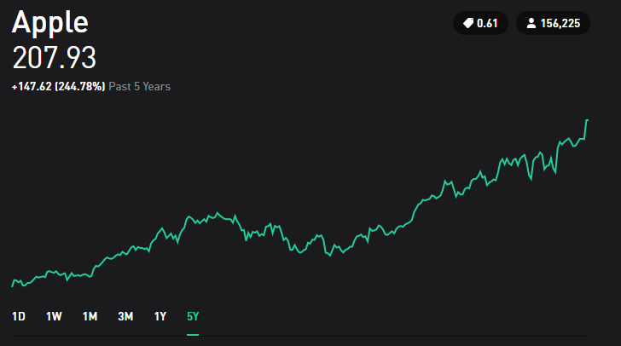

Apple’s Stock 2018

This upward trend, as the name implies is characterized by going “up” and it can be shown with a straight line going up as well. This trend tells us how well the company is doing, and how “Steep” the trend is, can tell us how efficient the company is compared to others. Now we will show 2 stocks that offer upward trends and a “linear approximation” in blue to see how steep each one of them is.

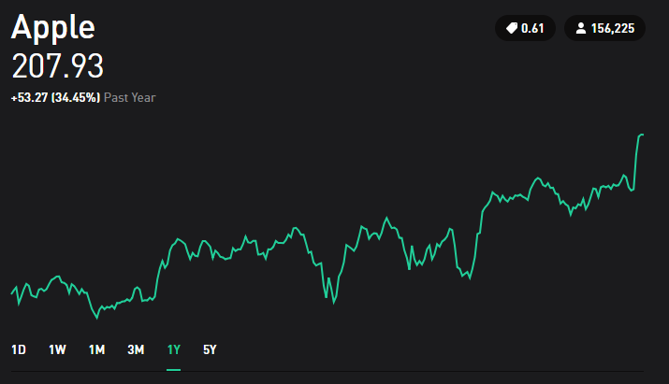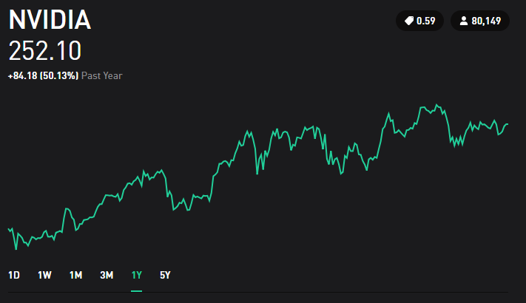

Comparison in between NVIDIA and Apples Stocks

Both show a linear increase, but it can be noticed that the linear approximation (in blue) for NVIDIA is steeper than Apple’s. Therefore, it would be determined that NVIDIA has shown more growth in their stock value. This can also be reinforced by looking at the percentage increases in both. Apple has 34.45% and NVIDIA has 50.13%. Even though this analysis seems simple, you can run through other platforms where information shows too many trends that can be really confusing for the early investors. To show how complicated this can get, let us see an example from Yahoo Finance that has some indicators

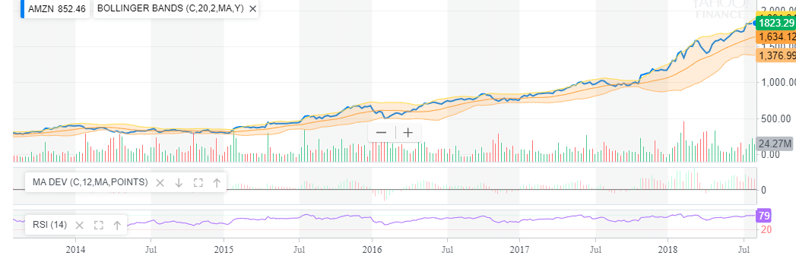

Amazon’s Stock from Yahoo Finance

This type of images should not discourage the early investors. When in doubt, always go back to the basics of identifying upwards trends. The key points to consider when looking at upwards trends are as follows:

* If you are comparing stocks, make sure they are being compared at the same length of time. Just as NVIDIA and Apple were compared earlier with 1 year of stock history, you need to always compare stocks with the same time of previous stock history. If you compare Apple’s history from last month to Microsoft’s history from last year to decide which one is better, you are not doing it right.
* When analyzing, make sure you are not being disappointed by daily changes. For this, we will take Spotify as an example.

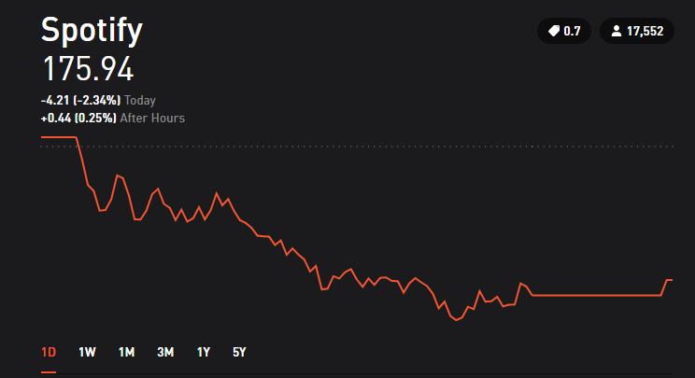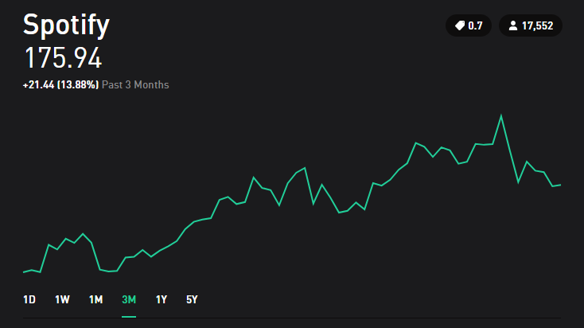

Spotify 1 Day vs 3 Month Trading history

If we look at Spotify’s trend for one day, it is obvious that the loss was considerably bad. However, if we look at the 3-month stock history, we notice how the stock in reality has generated 13.88% increase in price. So always remember that even if the company has had a bad day, does not mean that is doing bad. If you are wondering why I did not show the 5-year graph instead of the 3-month is because Spotify has less than 5 years on Robinhood, so it would not be as nice to see the upward trend. Even then, the upward trend is shown for Spotify on the 5-year graph. Now, most of early investors get disappointed by buying stocks and then in one day or week start getting loses and decide to sell the stock before losing more money. However, if they start looking at the long-term information they can deduct that the company has a high chance of giving return on the longer-term investments. **The longer the company has had their upward trend, the higher the chance that the company will keep giving you money on the long-term.**

* The reason why many investors don’t follow these ideas and start selling as soon as they see negative trends is because they want fast money. The reality is that even though is possible to make fast money on the stock market, it is unlikely and hard to achieve. So, the strategies and layouts on this guide serve again, for long-term investments.
* One safe baseline is to define upwards trends by **at least 1 year** of previous stock history. However, if the company does not have that much time in the market, more research might be needed given that it can be risky to invest in something rather new.

## Downward Trends or “Bearish” Trends

**These trends are the ones you need to avoid at all costs.** The reason to avoid these stocks is simply because they are going down. Some examples for downward trends are the following:

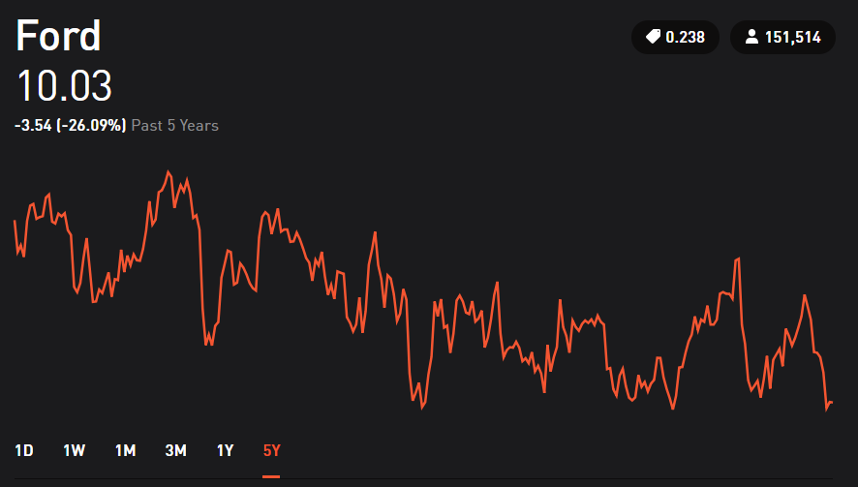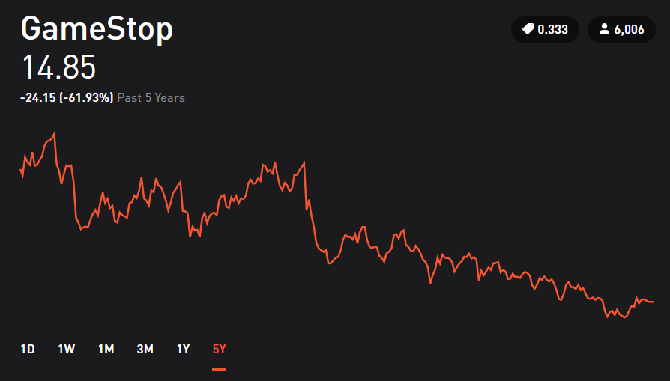

Downward Trend Examples

Some people argue that a downward trend is a sign that indicates that they will go up later. So, they buy the stock when price is decreasing, trying to find the exact time when it will start going up again. Some others argue that if the price once had a certain value, it must go back to that value eventually. **However, from personal research and experience, most (if not all) sources recommend avoiding this type of buying.** The reason behind it, is that there is too much risk involved in the company. Instead of trying to make money, people are focusing on just recovering back they had from that same stock. This can be dangerous because it can bring obstinance in their behavior and start believing price changes that could never happen.

This obstinate behavior is true for either long-term or short-term investments. An example is given for 22nd Century Group.

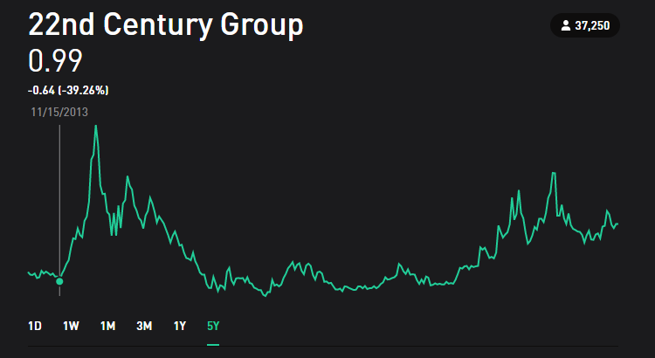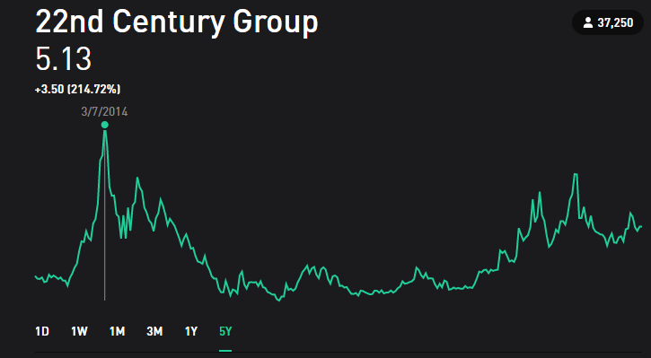

22nd Century Group in 2013 and 2014

If you bought stock in 2013, the value of it was about 1 dollar. After 4 months in 2014, the value of the stock grew 5 times of what it originally was. During this period of time, buying would be recommended. Excitement is high, and returns are good. Now let us look 4 months later, and 3 years later.

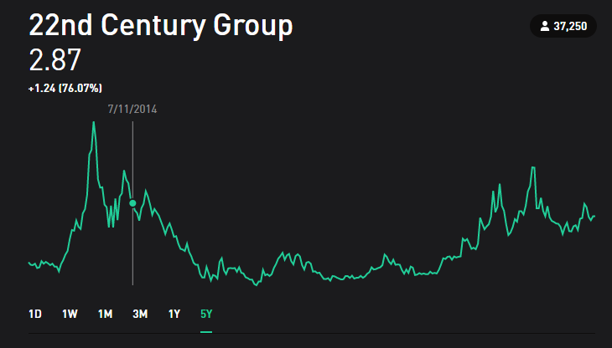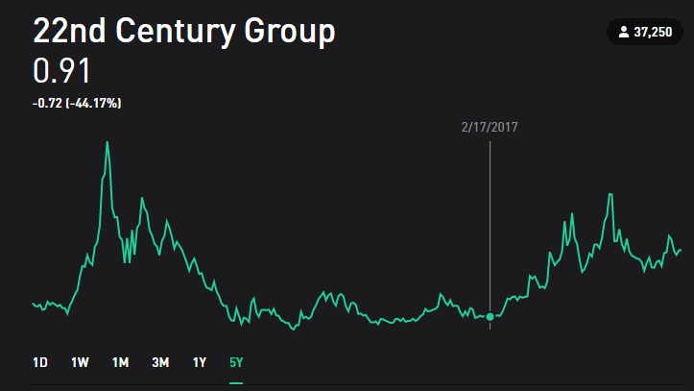

22nd Century Group in 2014 and 2017

Some investors way before this point of time would already have sold their stocks and kept their return instead of holding it longer waiting for more return. **But some investors could be on the idea that the price must go back to 5 dollars, even though they are on a downwards trend, decide to even buy more. That is not a wise move.** Three years later, the stock is valued even less than it was back in 2013. Looking at the history at 5 years, we can see how many investors won a lot of money and then some others lost a lot as well. This behavior of going down and then back up is possible, but is risky, that is why is not recommended for long-term investments.

**Remember, investments need to be taken from a logical perspective rather than an emotional one.** Whether you are disappointed with loses, whether you are very excited with profits, it is always recommended to be calm and anticipate how things can change.

## Horizontal Trends

**Horizontal Trends are attractive due to their low-risk characteristics.** The idea behind horizontal trends is that they tend to be constant. Horizontal Trends are not purely horizontal, they are in reality very little upward trending or very little downward trending. The key to this trend is to **always find horizontal trends with little upward behavior**. For now, let us illustrate that with two different investment type, an ETF and a stock.

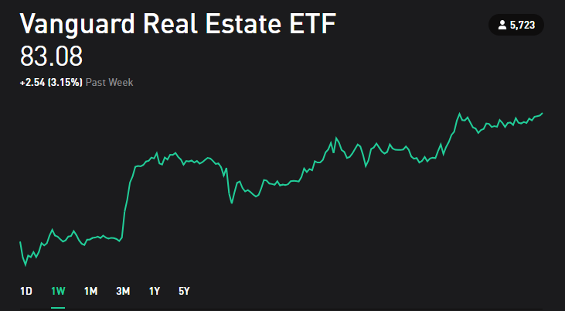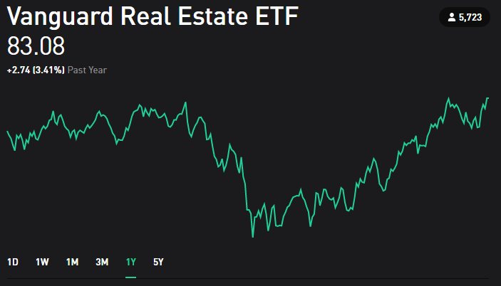

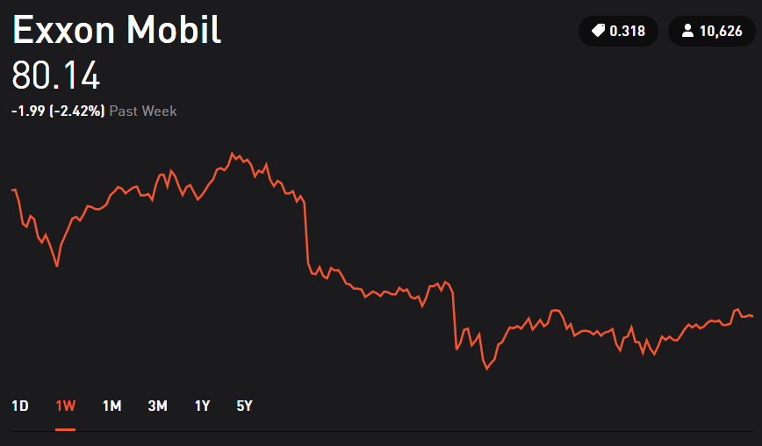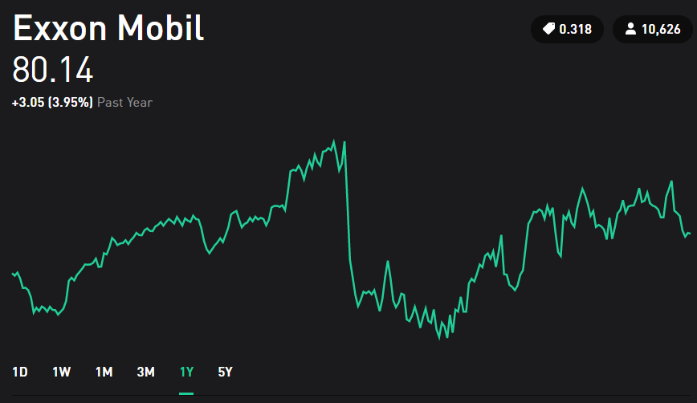

Horizontal Trends for Vanguard and Exxon Mobil at 1 Week and 1 Year

To identify a horizontal trend, we first look at the 1-year progress of both Vanguard and Exxon, in which both show a constant (or very little change) stock value. A key personal idea to identify a horizontal trend is looking at **two distant times (in this case, we look at 1 week and at 1 year) and we see how the progress of the stock circles around 5% change (or a small percentage change). This little margin of percentage gives us a good sign of a horizontal trend.** However, to verify that the stock is profitable we should focus on a stock that for the long-term has shown a positive increase. Now let us look at Vanguard and Exxon for 5 years.

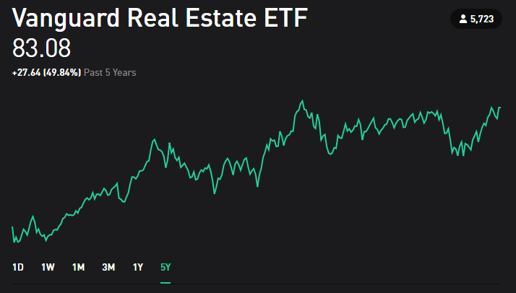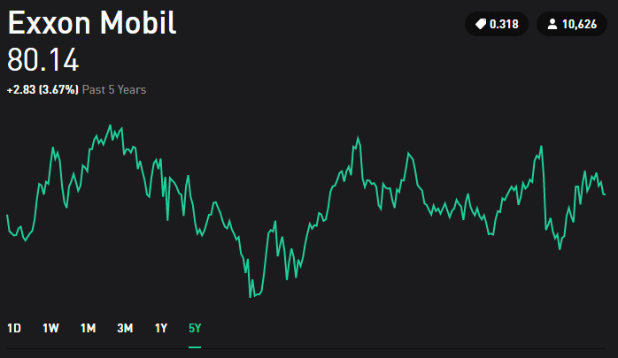

Horizontal Trends for Vanguard and Exxon Mobil

If we look at both graphs now, it is noticeable how Vanguard has had an upward trend for 5 years and a horizontal for about 1 year. In the other hand, Exxon still shows a horizontal trend. Given this information, both seem to be an example of an investment that will give low-risk returns, but Vanguard would show a higher rate than Exxon on the long-term investments. Note how this analysis worked for both an ETF and a Stock.

## Smaller Time Frame Trends

Depending on the amount of time history that you are looking, stock price can show different behavior. Taking Exxon for example:



Exxon Mobil – 1 Year History

The behavior instead of being “horizontal”, it seems more like an upward trend, followed by a high decrease, and then another upward trend. If we were to split this graph into 2 sections where one represents 6 months, and the other one 6 months as well, both graphs would have an upward trend. **So many investors decide to break the history of stock prices into smaller sections to predict patterns at smaller time frames.**

However, this is mainly done for other types of trading such as day trading or swing trading. **By looking at the overall trend of a large span of time, we stop worrying about what happened in between.** That is one of the advantages of long-term investments, that it is not so crucial to see the smaller time trends because we pay attention to the overall shape of the graph. Depending on the necessities or willingness for risks of the investors, looking into these patterns is worthwhile. Readings on this topic are recommended on the Suggested Readings.

One big advantage of splitting the graph in smaller time frames is that we can identify what is the behavior of the stock during specific time periods. This brings to the next main topic.

## What Affects Trends?

Just because we identify a trend does not mean that it will always stay that way. Sometimes the trends are affected for specific events that many people are not aware of. **It is important to note that a stock’s value reflects how well a company offers services or sell products.** So how their products are sold, how well their services are doing, how the public sees the company and many more factors affect these trends. And now the most important factor in this section: **Not everything about a stock can be predicted by looking only at the graphs.**

**Quick-Example #1 Popularity and Reputation Matter**: If you go to a place where customer service is excellent, the products are really popular and a lot of people you know shop or pay services on this company, then you already have many good signs of how the stock of company should be doing. On the contrary, if the company you are analyzing, has really bad reviews, people don’t ever or stopped going to this company, you can see that this behavior are heavily reflected on the company’s stock. Let us take for product example: Netflix and Blockbuster. Nowadays, everyone has a Netflix account. Most people when talking about movies or series, they refer to Netflix or similar competitors. On the other side, Blockbuster is a company that recently reached bankruptcy. However, for the past 5 years that it was still on the market, nobody would ever mention it, it was uncommon to hear about people going to buy products at Blockbuster.

**Quick-Example #2 Some Businesses are Season-Dependent:** Stocks are representative of a business. So there exists businesses where the time of the year is significant. If you go to a clothing store that focuses on selling winter clothing, then you would not be surprised to see that the earnings of the company and stock prices usually are higher on winter seasons, and then low on summer seasons. Pay attention to the seasons in which businesses work.

The factors that affect trends, are too many to just explain in one chapter. The idea of this chapter was to explain how different trends are identified and how they behave. **The final note on this chapter is to always remember that the time frame that we look at things plays a huge role in our understanding of stocks.** Furthermore, there are other key things to understand before developing a complete strategy in stock trading. These key things are the next chapter.

# Chapter 4: Classifications of Stocks

Previously we looked at how different trends can be analyzed. One of the tools during this analysis is to understand in which classification our stocks fall into. These classifications will help us to understand the trends before we even look at them. There will be two levels of classification.

## Level 1 - Volatile and Constant Stocks

All stocks can fall in one of these two options. As the names easily imply. One of them is Volatile Stocks, these stocks tend to change in trends really fast. One day they could be going up in price with profits of more than 20%, and the next they could be falling price drops of 50%. This **volatile behavior** is usually characteristic of businesses that are not fully developed or recently started. **For long-term investment, it is important to avoid this type of stocks.** On the other hand, constant stocks, are stocks that show similar trends for most of the time. Usually constant stocks don’t truly exist, and investors call them low volatility stocks, but for this guide, they will be called constant. There will be moments where these stocks can be high or low for a short period of time, but these events are usually rare. **For long-term investment, it is important to identify this type of stocks.** **Overall, volatile stocks are really hard to predict even on the long-term and constant stocks are easier to predict on the long-term.**

## Level 2 - Service/Product Stocks

Now that we understand the two general types of stocks, let us look at service/product classification. In simple terms, this means that we can classify stocks as categories such as: Technology Stocks, Finance Stocks, Food Provider Stocks, Gaming Industry Stock, and many more. The list could go on for many categories, and even in the future some of them could disappear whereas some other might be totally new. For example, VHS tapes have disappeared, and online streaming services took over this market. Now, why is this important? **Because this type of classification tends to offer some predictable patterns.** Let us look at the telecommunications industry.

Robinhood note: Every time that you click on a company, the app or the website offers a list recommendation of the company. Similar to this:

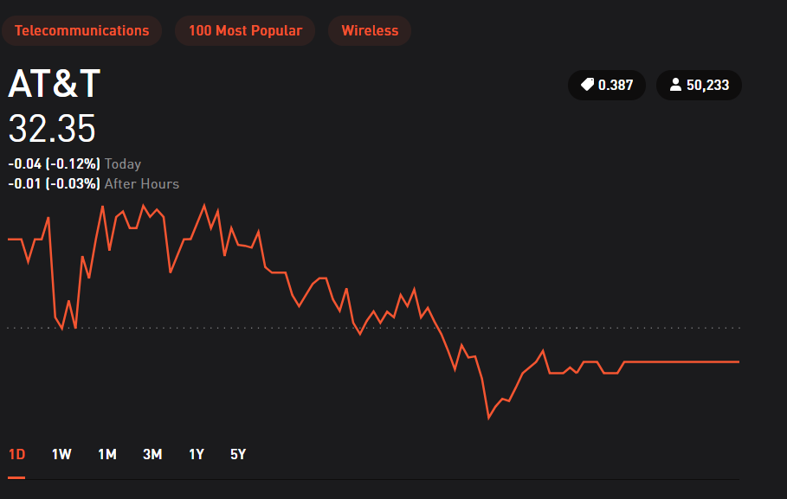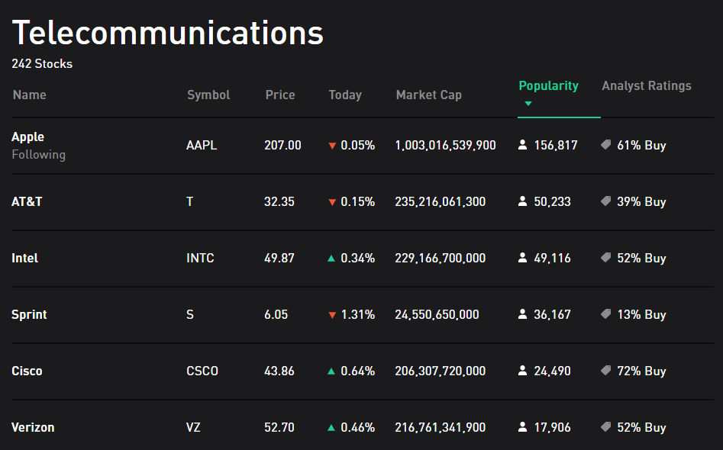

Category Example Selection

Many industries fall in this category, and each one of them is different in price. However, let us explore the idea on how they behave similarly. First 4 of these stocks are chosen for explanations and shown in the following images:

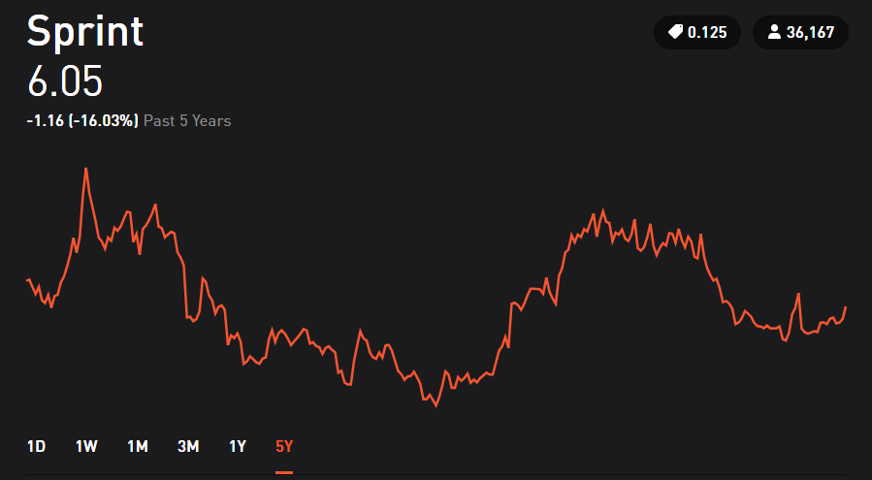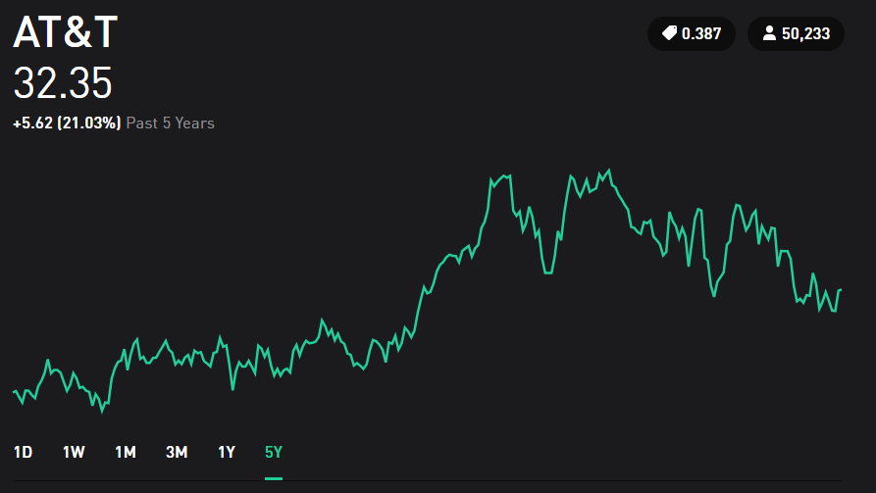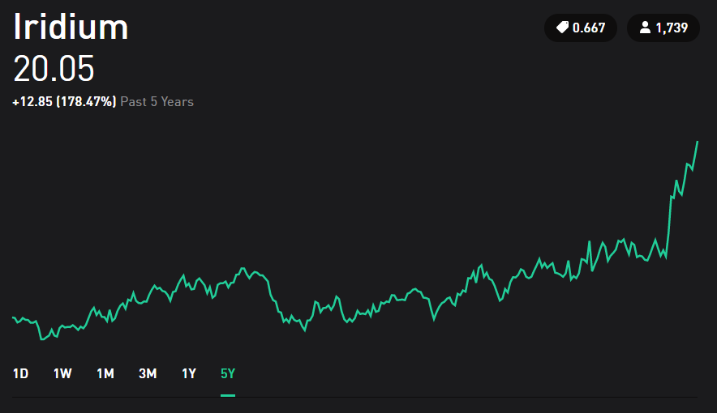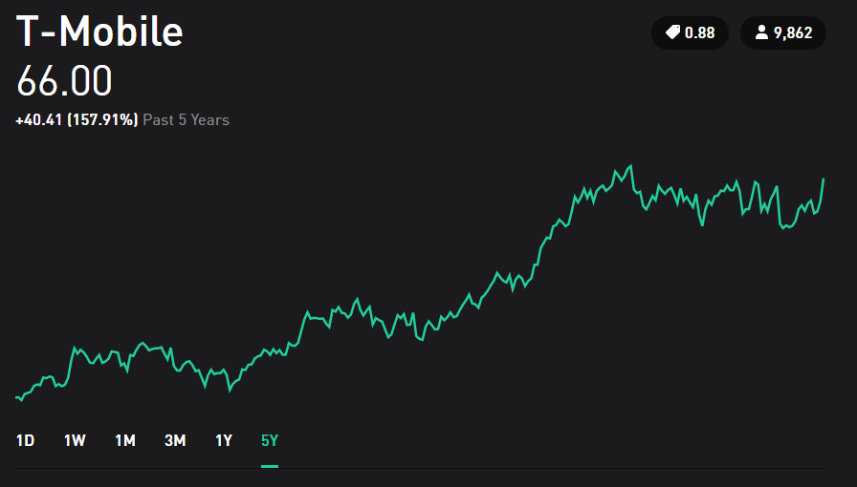

Stocks Comparison in the Telecommunication Area

Each stock has very different price, and each one of them has very different percentage of return. Also note how we are making this comparison in between each other with the same time frame of 5 years. Now, by looking at this information **we can infer about telecommunication industries is that their behavior tends to be constant and secured.** As a long-term investor, the telecommunications market seems a profitable constant source of money based on this. Of course, not of all of them will be generating profits as Sprint shows. However, based on our strategies and knowledge we will choose which of these stocks would be the most fruitful.

## Remarks

In general, public services such as water, electricity, and many more, tend to offer a constant and secured cash flow coming to your portfolio. Some other areas such as technology, automotive, or game industries tend to have a higher volatility (or unpredictable behavior). So now, based on the service or product, we can deduce a little bit about how the trends should look. To summarize this chapter, the following graph is provided:

*Company Example*

*Level 1*

*Level 2*

Virtual Reality

Product

Volatile

Drone Delivery

Service

Stocks

Food and Computers

Constant or Low-Volatile

Product

Electricity and Water

Service

Stocks Comparison in the Telecommunication Area

Sometimes, companies can offer both products or services, in which deducing their volatility can be trickier. Note that the examples above could be simplified as:

* Everyday products and services tend to be constant
* New Technology tend to have volatile behavior

The list examples on the blue area could be going on for many categories, but the idea is to be able to see how different companies can have a somewhat “predictable behavior” before even looking at their history. **The reason for new technology or new companies to be so volatile is because both options of success or failure are somewhat equal.** There are cases where one or two companies might be ahead of the technology race than others. But that is the job of investors to find those companies before their products or services become a huge success.

Robinhood note: By looking into Robinhood, it offers a section to see the volatility of a stock. Robinhood categorizes stocks as High, Medium or Low Volatility. They use a different methodology for this classification. For example, in High Volatility they include penny stocks and some ETFs. Each investor can develop their own way to classify their stocks. But remember that Robinhood or any platform that offers these “volatility measurements” can assign them with very different parameters such as: price value, stock type, history of stock, time frame being considered and many more.

# Chapter 5: Stock Trading Strategies

Now that we now all investment types, and we know how stocks behave, we need to understand what to do with those behaviors. This chapter will briefly explain how different trading strategies were first developed, and then give a brief overview on different strategies and how they work. This information will not be enough to do trading on the specific strategy, but to give general knowledge about them to the reader.

## How to Predict Trends?

For starters, **there is no absolute way to predict trends in this world.** Even the most famous and successful investors like Warren Buffet have failed to predict stock prices. Also, every single person is different, and the predictions of everyone will be different as well. For this reason, Stock Trading Strategies were created. These strategies vary depending on many questions such as:

* How fast do you want to make money?
* How much money am I willing to risk?
* How secure do I want my investments to be?
* How much time am I going to dedicate to stock trading?

These questions were pondered by many inventors before coming with different trading strategies. For this guide, we will give a brief explanation on some of the most popular strategies available. We will focus in detail on only a very brief selections of these styles for next chapter.

## Trading Strategies List

**Day Trading:** Focuses on finding upwards trends in short amounts of time (hours) and then buy when the price is predicted to keep going up. Then sell when the value of the stock is starting to decrease. The method is risky because requires constantly trading to generate profits.

**Swing Trading:** This trading strategy is like Day Trading but the amount of time for holding a stock is longer (usually days to weeks). This method involves the same idea of buying when the prices is predicted to keep going up for a couple of days and then sell when the value starts to decrease. This strategy is less risky than day trading but still riskier than traditional long-term investments.

**Trend Trading:** Very similar to Reversal Trading, but instead of going “up, down and then up”, the behavior can be quite different. The idea is to find a repeated pattern, could be a mixture of many ups and downs. After identifying this pattern, the objective is to buy the point of the pattern with the cheapest price and sell at the point with the highest price

**Momentum Trading:** Usually investors always seek to “buy low and sell high”. Momentum Trading instead focuses on trends that are “buying high and sell higher”. The time for this strategy can vary from hours to days. The longer a stock is hold, the longer the risk is.

**Reversal Trading:** Reversal means that the stock price is going up, then it goes down, and then will go up again. Investors that look for this pattern concentrate on finding the cheapest price before it goes back up. This technique again serves from hours to weeks. Similarly, to other strategies, the longer the stock is hold, the higher the risk it entails.

Remember that if you want to use any of these strategies, you need to research in detail for the one you want to focus. This was just an overview of some (but not all) strategies. Some people come up with their own trading style that is different from what exists.

For the rest of this guide we will focus on one single trading style that can generate secure profits if used wisely. If you want to learn more about other trading styles, Suggested Readings have some recommendations for that.

# Chapter 6: The Suggested Stock Trading Strategy

The first 5 chapters offered the basic knowledge every investor should be aware off and be prepared to consider when making investment moves. From this Chapter on, all the information provided will be referring to how make profits with a stock investment strategy. But first, let us summarize everything we have covered so far.

## Summary of Previous Chapters

Up to now we have covered:

* Different Investment Types
* We focused on Stock Trading Only
* Within Stock Trading there are Basic Trend Classification (Upward, Downward, Horizontal)
* All stocks have those Basic Trend Classifications
* Different Stock Classification Which had two levels: Level 1 (volatility) and Level 2 (product/service)
* Depending on all the stocks categories mentioned before, different trading techniques exist.

It is important to note that up to this point, a beginner should have the essential knowledge to understand what traders do and how stocks can behave. The following image summarizes all this exploring we have gone through and highlights our main objectives which are: Invest in Stocks for Long-Term Trading. Remember that all trend classification and volatility classification work for other forms of investment as well.

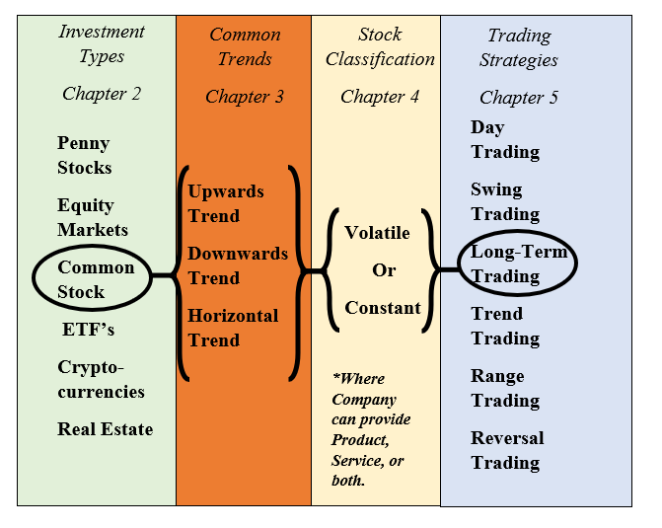

Summary of Previous Chapters on How Investments Work

Now we will **only focus in detail on one** stock trading strategy, rather than explain general ideas of everything that there is out in the world of trading. For the beginner, the next sections will offer you one trading style, but to invest in different investment types or more trading style, it is recommended to explore further into those. Recall the Suggested Readings to learn about other types of trading or investment.

## Long-Term Investments on Stocks

Previously, it was mentioned that the reason for new technology or new companies to be so volatile is because both options of success or failure are somewhat equal. With the idea that you have 50% of making a fortune and 50% of losing everything, **it could be considered gambling.**

Beginner investors fall for the idea that reading some articles on how the performance of a stock will be is enough to make a purchase decision. However, that should not be the case. The more you investigate and develop an understanding about the stock market, your decisions will shift from a gamble to a strategy. The key ideas from this guide to generate profits are as follows (and remember based on experience you can create your own):

* If a Stock has an Upward Trend going for many years, it will probably stay that way on the long-term.
  + The opposite is true for Downward Trend
* Research the company you are investing in. A lot.
  + There will be many examples on Chapter 7 that show how a company can be analyzed that goes beyond from just reading a couple of articles on the stocks.
* Concentrate on Continuous Growth.
  + Even if its small. Growth on the long-term becomes big.
* Diversification is key. More details after this list.
* Do not get impulsive over one day movements. For long-term investments, you should not monitor every hour how your stock is doing
  + This is hard for beginners, but always be patient.
* Avoid Downward Trends
  + Also avoid Horizontal Trends with very little downward behavior.
* Do not invest money you cannot afford to lose.
  + Never use forms of debt (like credit cards) to invest on stocks, first pay your bills.
* Do not believe everything you read from the internet that was written by a person.
  + That is an opinion that could be either true or false.
* Trust more the numbers, and information from the company, that has no personal input.
  + However, be smart on how you interpret those numbers.
* Do not get confident in or attached to stocks.
  + At the end, everything is possible.
* Always be open to learn.
  + The more books you read, the more you can become better at predicting stocks.

Now that we have covered the key points for long-term investments, let us go in detail for some of them.

## Diversification

**Diversification** is a common term in the world of investors, and its meaning is simple. Though, we can elaborate a little bit to understand the importance of have a “Diversified Portfolio”. Usually, when somebody is using diversification it means that you are purchasing stocks from many types of companies. For example, some of your money is in Food Stocks, some other is in Energy Stocks, some other is in Sports Stocks. The idea is that all of them are different **Why? Because, a sector of the market could go down in any moment.** Let us take for example the oil industry. If all your money is invested oil industries, right now there will be income generated, but if you are not careful, in the future there exists the possibility for all oil industries to do bad in the case of an oil-scarce situation. If that is the case, you would lose all your investments in matter of days. If only 10% of all your money is in the oil industry, however, this oil-scarce situation would not make you lose all your investments. This situation seems not likely within the next 10 years or so, but it is just to illustrate the idea.

**Diversification can be considered from a perspective of volatility as well.** We previously saw how stocks can be considered volatile or constant. For long-term investments, it is always recommended to avoid volatile stocks. But if you want to have the chance of skyrocketing your investments, dedicate a safe percentage of your money (usually less than 20% of all your investments) to volatile stocks. That way you have a diverse and safe portfolio that will generate money on the long-term while have a chance to generate big profits for that 20% of risked money. **But always be cautious on where you spend that money. Research on volatile stocks is always harder and trickier to predict.**

**Diversification can consider other investments that are not stocks.** Now that you know many different investment types (such as real estate, cryptocurrencies, and so on), you could consider those as well to be part of your portfolio. This guide will not cover how much percentage of your money should go to each of these investment types because all of them are different and each one of them have more rules to them. However, if you have a portfolio that has 40% invested on real estate and the other 60% on stocks, that would be considered diversification as well.

**Quick-Example #3 Diversify your investments**: This will serve as basic example of a diversified portfolio.

* 15% Volatile Stocks
  + Where this could be technology stocks, or new companies recently arising.
* 65% Constant Stocks
  + Where these focus on continuous growth and upward trends for long-terms
* 20% Other type of Investment
  + Where these could be real estate, ETFs, Index Funds, etc.

Some investors with more experience might consider these percentages as not appropriate and could recommend following a different scheme than this one for either: risking more money or securing more money. So, remember that you need to understand your financial situations to determine how much can you invest and where to invest. Some investors might even recommend avoiding individual stocks at all and focus on Mutual Funds or other forms of investments. But remember, everyone has different approaches and this guide is focusing on Long-Term Stocks Investments.

# Chapter 7: Quick Example List with Strategies

This section has a list of all the Quick-Examples shown in the guide plus some extra examples to illustrate more important points. The final three Chapters 6, 7 and 8 offer a “go-to-section” when you begin your journey on investment. It is recommended to always think on the Suggested Stock Trading Strategy along with the Quick-Examples to make decisions about purchasing stock. The reason for these chapters to be at the end is because these are not “set in stone” principles that will always apply but just “things to keep in mind”. **Nobody will predict the future 100% of the time, but it is up to us to keep our predictions right for more than 60% of the time, and profit will be huge.**

## Quick-Example List

*Previous Examples shown in this guide:*

**Quick-Example #1 Popularity and Reputation Matter: Page 22**

**Quick-Example #2 Some Businesses are Season-Dependent: Page 23**

**Quick-Example #3 Diversify your investments: Page 32**

*New Examples for consideration:*

**Quick-Example #4** **IPOs Create Commotion:** Earlier on Chapter 2, IPO’s were explained as a form to generate capital (money) by putting their stocks on the market. When this happens, many investors tend to get excited about being able to purchase stock for a company that was not available before. The companies that get greatly affected by IPOs are companies that were popular before the IPO. Let us take for example Snapchat. This company’s IPO was in 2017 with a price of about $24. Given that Snapchat had a high popularity back then, it was logical that many investors would see a profitable opportunity in buying this company’s stock. Given that popularity, prices skyrocketed for the Stock going up to about $30 some dollars within just a couple of days. However, after weeks the stock plummeted to less than $20 and people started to panic about it. Finally, it went down to a price below $15 where it currently stands. **Why did this happen?**

This happened because many investors only considered the popularity factor instead of analyzing other circumstances. We need to remember that the amount of money a company has is dependent on two things: How much you owe and how much you make (recall the Basic Accounting Equation from Chapter 2). Because of this, the value of the stock went up **because IPOs created commotion**, and the company received a lot of money from investors. However, for a company to maintain that high increase in value, you need to get money from sales or profits, not only what you owe. We recall that Snapchat is a mobile application for social media that does not have many “money sources”. If we explore Snapchat’s history we see that it has some advertisements on it, but that is about it. Snapchat doesn’t support computers, so accessing websites to make money was not an option. The more we investigate about Snapchat the more we see that it can make profit, but not as much as it seems. For this reason, the price of the stock goes up, and then after a while of not being able to make enough profits, the price will go down. Experienced investors might make the move to buy Snapchat at its IPO value, hold it until it reached a high value of return (about 20%) and **then sell it since they saw that the company would not seem profitable on the long-term.** This type of strategy is valid for long-term investors who see chance of making extra money for buying and selling within two or three days. **Developing this kind of decisions comes from understanding that IPOs create commotion and that you need to learn and understand the company you are buying.**

**Quick-Example #5 Companies are like People offering Business Ideas:** To illustrate this, think about three people. One of them is a total stranger. The other two are your friends, but one of them you know him to be responsible and the other one is not responsible at all. Let’s say that all three of them have the same business idea and they ask you to lend them a lot of money for their idea. **Who would you give the money to?** The answer is simple, but personally I would give my money to my friend that I know is very responsible. Why? Because I know him to be responsible from a long time and I know he will pay me back and give me more if his business is successful. Why would I not lend money to the other two people? Well, I know my other friend well enough to know that he is not going to carry out the business idea properly and I might not get my money back. The stranger actually has both options of being either successful or a failure, but I don’t really know enough information to make a decision from him. Stocks work literally the same way. **The more you know about it, you can tell if it’s a good idea to invest or not. Also, if you don’t know anything about the stock, you need to first learn a lot before even considering investing in that company.**

**Quick-Example #6 Comparing Apples to Apples:** When it comes to investing, some decisions involve in distinguishing in between two similar companies with different stock prices. If both companies offer the same product or service, what makes them different in terms of stock prices? There are different aspects that we have discussed before from Chapter 2. Sometimes companies have small number of shares and that increases the stock prices. Some of them have a lot of shares, so the prices are lower. Now, **if both companies have the same number of shares (but really different prices), what is happening?**

The examples shown in this section are just some out of many examples possible. The more experience you learn, and the more you read, you will be able to make better and more profitable decisions. Remember that it is not possible to predict everything with certainty, but the key is to be intelligent about investments and never let your emotions to carry away your decisions.

# Chapter 8: Key Summary, Pro-Tips and Suggested Readings

This chapter has a summary section for future reference, and some final notes to consider about investing that are not related to the aforementioned strategies.

* Focus on constant growth rather than immediate rewards.
* Investing on Stocks requires knowledge about the company you are investing and understanding many circumstances in which the company might be successful or not.
* Never let your emotions to cloud your thoughts.
* Nobody can’t predict with 100% certainty the future.
* Do not trust only one article or piece of information. Instead, gather as many articles or pieces of information as possible.
* Before trying an investment or a trading style, always research it.
* Asses your risks and never invest money that you cannot afford to lose.
* Diversification is key for an investor. The more money sources you have, the higher the likelihood of generating income.
* Historically, the market always goes up. Therefore, long-term investments, if selected correctly, will generate a steady return.

Because they are always useful, here are some **Pro-Tips** that are not directly related to stock trading, but are equally as important to success:

* Learn how to save money, every dollar not spent, is an extra dollar invested.
* Pay all your debt. It doesn’t matter how much money you have saved, or how much money you have invested if you have debt. Debt increases a similar fashion as investments. So, similar to how investments are better on the long-run. Debt is worse on the long-term.
* Always keep in mind: **Becoming financially independent comes from how you save and invest, not how much you make.** Therefore, whatever your financial sitation might be at this very moment, success can always be attained.
* Remember that investing has a certain “emotional” attachment to it that many people don’t recognize. Be smart on your decisions and rationalize them. Don’t let your pride make the decisions for you.
* Keep reading about getting better. The more you know, the more value you can add to your wealth. Don’t be limited to learn only about investments, books about many topics can be helpful to develop new skills or new mentalities that will achieve your goals.

## Notes to consider:

Experienced investors might know that there are **financial ratios** and parameters that are often used into analyzing stocks. Some include: Beta, Price Earnings Ratio, Earnings Per Share, and many more. These are important tools that investors can use to understand stocks. However, **there is no value to calculating or looking at financial ratios if we don’t understand the market from a common-sense point of view first.** Throwing ratios and explaining them might seem like a provision of tools you need and must use. But ratios are tricky without the useful mentality and trend analysis we have described throughout this guide. All trading platforms and many online sources such as Yahoo Finance provide these financial ratios and parameters, but remember that to first understand the numbers, you need to understand where they come from. Which is the key-learning objective of this guide. To create a common-sense mentality of how stocks behave.

If you are a first-time investor, it is important to know that any form of investment must be added to your Tax Return. This guide will not go over any details on taxes, but many early investors might forget or might not know that it is important to consider taxes when you invest.

## Suggested Readings

This section is a list of many sources that are recommended to beginners and remember to keep learning. One key for success in the stock market is to always be open to learning and adapt to changes. Regardless of the strategy you follow, always read, always try, and always learn. Thank you for reading this! Remember, **The Finale for this Guide, is the Beginning of your Wealth.**

* *Websites on Investing:*
  + Investopedia
  + The Motley Fool
  + Yahoo Finance
* *Books on Investor Mentality:*
  + How to Think like a Millionaire – Frank Fisher
  + The Science of Getting Rich – Wallace D. Wattles
* *Initial Books on Other Trading Strategies:* 
  + The Index Fund Solution – Richard E. Evans
  + Penny Stocks for Dummies – Peter Leeds
  + How to Day Trade for a Living – Andrew Aziz
* *Classics of Investing:*
  + Business Adventures: Twelve Classic Tales from the World of Wall Street – John Brooks
  + The Intelligent Investor: The Definitive Book on Value Investing – Benjamin Graham
  + The Little Book of Common Sense Investing – John. C. Bogle
  + A Random Walk down Wall Street: The Time-tested Strategy for Successful Investing – Burton G. Malkiel